006BC2744 - Day 13 (3 August 2026)

Task 1: What is an ER diagram? Draw an entity relationship diagram with datatypes.

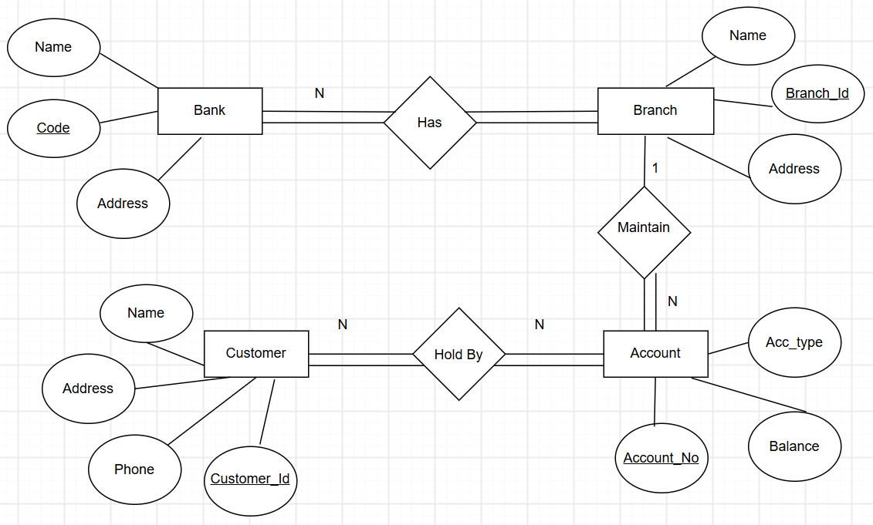

An ER (Entity-Relationship) Diagram is a visual representation of a database that shows entities (tables), their attributes (columns), and relationships between them.
It helps in designing and understanding the database structure before creating the actual tables.

Task 2: What do you understand by indexing in DBMS? How does it work?

Indexing in DBMS is a technique used to speed up data retrieval from a table, similar to an index in a book. It creates a separate data structure (such as a B-tree) that stores key values and references to the corresponding rows, allowing the database to find data faster without scanning the entire table.

Task 3: Do you think Indexing strategy improves the query performance ? explain.

Yes. Indexing can significantly improve query performance by allowing the database to find matching rows quickly instead of scanning the entire table.
However, too many indexes can slow down INSERT, UPDATE, and DELETE operations because the indexes also need to be updated.
Task 4: What are the ACID properties in RDBMS? Explain.

ACID properties ensure reliable and consistent database transactions:
- Atomicity: A transaction is completed fully or not at all.
- Consistency: Data remains valid before and after the transaction.
- Isolation: Concurrent transactions do not interfere with each other.
- Durability: Once committed, changes are permanently saved.

Task 5: Alter a table to add a column with unique key

Task 6: Add a check constraint to your column (eg: balance > 0)

Task 7: use where clause and check if it works

Task 8: Use order by

Task 9: use limit

Task 10: Create queries for left outer join
Right outer join
Inner join
Cross join

Solution for task 1-10:

CREATE TABLE Accounts (
id SERIAL,
custName VARCHAR(10)
);

INSERT INTO Accounts (custName)
VALUES ('Bharggav');

INSERT INTO Accounts (custName)
VALUES ('Ram');

INSERT INTO Accounts (custName)
VALUES ('Krsna');

select * from Accounts;

select id, custName from Accounts where id = 1 and custName = 'Bharggav';

truncate table Accounts;

drop table Accounts;

create table Customer (id int primary key, name varchar(20), age int);

select * from Customer;

alter table Customer alter column id add generated by default as identity;

insert into Customer (name, age) values('Rama', 29);

insert into Customer (name, age) values('Sita', 20);

insert into Customer (name, age) values('Lakshmana', 29);

insert into Customer (id, name, age) values(1, 'Ravana', 29);

BEGIN;
-- INSERT INTO Customer VALUES (104, 'Urmila', 20);
-- INSERT INTO Customer VALUES (105, 'Raghava', 45);
insert into Customer (id, name, age) values(1, 'Ravana', 29);
COMMIT;

ROLLBACK;

alter table Customer add column email varchar(50) unique;

update Customer set email = 'rama@gmail.com' where id = 1;

alter table Customer add constraint age_check check (age > 18);

insert into Customer (id, name, age, email) values(101, 'Ravana', 15, 'ravana@gmail.com');

select * from Customer where id = 104 and age = 20;

select * from Customer order by age asc;

select * from Customer order by age desc;

select * from Customer order by age asc limit 2;

create table frontend_developers (
id int primary key,
name varchar(20),
project_id varchar(20)
);

insert into frontend_developers values (101, 'Ashok', 'P01');
insert into frontend_developers values (102, 'Kishore', 'P02');
insert into frontend_developers values (103, 'Sagar', 'P03');
insert into frontend_developers values (104, 'Hitesh', 'P04');
insert into frontend_developers values (105, 'Hari', 'P44');
insert into frontend_developers values (106, 'Bharggav', 'P45');
insert into frontend_developers values (107, 'Rama', 'P46');

select * from frontend_developers;

create table backend_developers (
id int primary key,
name varchar(20),
project_id varchar(20)
);

insert into backend_developers values (111, 'Sam', 'P11');
insert into backend_developers values (122, 'Ritu', 'P22');
insert into backend_developers values (103, 'Sagar', 'P33');
insert into backend_developers values (144, 'Nikky', 'P44');
insert into backend_developers values (145, 'Hari', 'P44');
insert into backend_developers values (147, 'Bharggav', 'P45');
insert into backend_developers values (107, 'Rama', 'P46');
insert into backend_developers values (108, 'Sita', 'P46');

select * from backend_developers;

select * from frontend_developers inner join backend_developers on
frontend_developers.project_id = backend_developers.project_id;

select f1.id, f1.name, f1.project_id from frontend_developers f1 left join backend_developers b1 on f1.project_id = b1.project_id;

Task 11: Try playing with indexes on your table.. And see the performance it should increase the query performance.

CREATE INDEX idx_customer_age ON Customer(age);

SELECT * FROM Customer WHERE age = 50;
PostgreSQL may use idx_customer_age to find the matching row faster.

CREATE UNIQUE INDEX idx_customer_email ON Customer(email);

SELECT * FROM Customer WHERE email = 'rama@gmail.com';
If email already has a UNIQUE constraint, PostgreSQL already creates a unique index automatically, so you don't need to create another one.

Task 12: Schemas
Trying creating a schema .. and inside create a table ..

CREATE SCHEMA bank;

CREATE TABLE bank.Customer (
id INT PRIMARY KEY,
name VARCHAR(20),
age INT
);

INSERT INTO bank.Customer
VALUES (101, 'Rama', 50);

SELECT *
FROM bank.Customer;

ALTER SCHEMA bank
RENAME TO banking;

DROP SCHEMA bank;

This works only if the schema is empty.

If it contains tables/objects:
DROP SCHEMA bank CASCADE;

Task 13/14: Can you create a java code and connect with the postgresql

<dependency>
<groupId>org.postgresql</groupId>
<artifactId>postgresql</artifactId>
<version>42.7.13</version>
<scope>compile</scope>
</dependency>

# PostgreSQL Database Configuration
spring.datasource.url=jdbc:postgresql://localhost:5432/BankDB
spring.datasource.username=postgres
spring.datasource.password=postgres

# PostgreSQL Driver
spring.datasource.driver-class-name=org.postgresql.Driver

# JPA / Hibernate Configuration
spring.jpa.hibernate.ddl-auto=update
spring.jpa.show-sql=true
spring.jpa.properties.hibernate.format_sql=true

# Hibernate Dialect
spring.jpa.database-platform=org.hibernate.dialect.PostgreSQLDialect

